**Download and Install Spring Tool Suite (Spring Tools 4 for Eclipse) IDE**

Prerequisite: Make sure you have installed Java Development Kit (JDK) version 8 or newer. To check simply go to the terminal and enter the below command to check if it is present or not.

javac -version

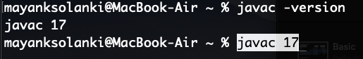

Procedure: These are steps to be followed sequentially which are discussed further with visual aids as listed:

1. Download SpringToolSuite as per the operating system to the local machine.
2. Move the downloaded JAR file to the corresponding folder.
3. Unzip this JAR file and open the corresponding folder.
4. Click on the SpringToolSuite4 Application file
5. Select the directory representing workspace and press the ‘LAUNCH’ button.

Step 1: Go to their website and in Spring Tools 4 for the Eclipse section in order to download. choose your corresponding file according to your OS.

Here we are going with Windows operating systems so do we have chosen Windows option as seen in the below image.

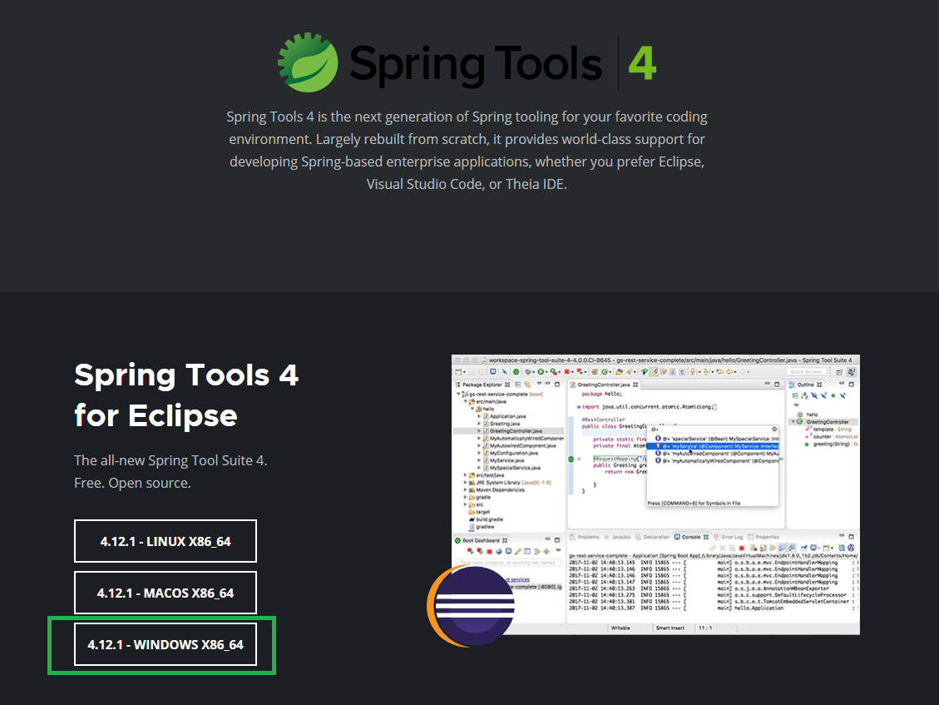

Step 2: After clicking on the button a Jar file will be downloaded to your local system. Now create a folder and move this Jar file to that folder. And double-click on that Jar file. A pop-up window will appear like this.

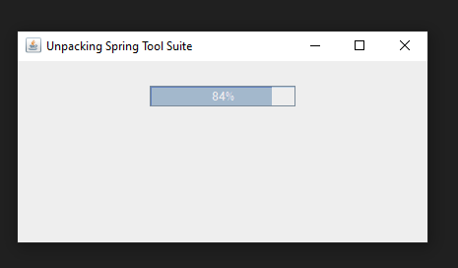

Step 3: After successfully Unpacking a new folder will create as shown in the below image. Now open the folder.

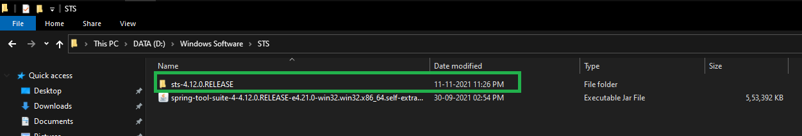

Step 4: In this folder now click on the SpringToolSuite4 Application file as shown in the below image. 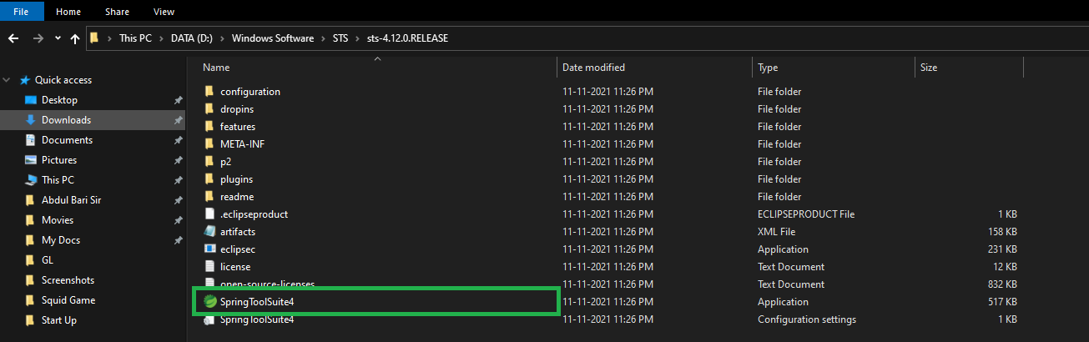

Step 5: Now select your directory as workspace by clicking on the Browse button and then click on the Launch button. And you are done

. 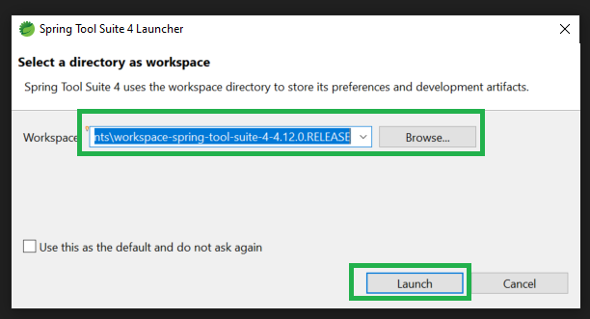

This is the Home screen for Spring Tool Suite (Spring Tools 4 for Eclipse) IDE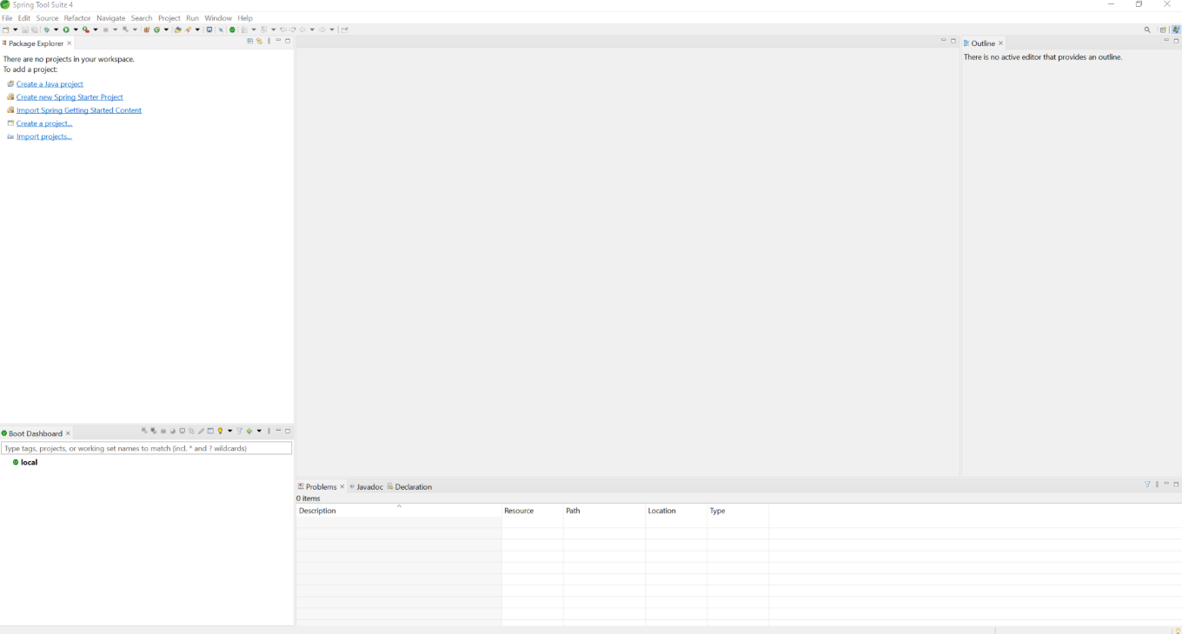

**Happy Coding**